
Detection and Prevention of DoS Attack Using Machine Learning Techniques
ICT607- Artificial Intelligence for Cyber Security
Group 16 – Project Proposal
Jyothi Ravipati - 34784275
E.H. Dinuka Sandaruwan – 35048058
Van Sanh VU – 34900798
Muhammad Danyal Khan - 34721903
Contents
Executive Summary 1
Cyber Security Task: Intrusion Detection (Network) 2
Justifications for selecting DoS Attack Detection 3
Objectives of the Cyber Security Task 3
Dataset – UNSW – NB15 3
Dataset Description 3
Characteristics of the Dataset 4
ML Algorithms 5
Random Forest 7
Support Vector Machine (SVM) 8
Potential Challenges & Mitigation Strategies 10
References 11

Executive Summary
Denial-of-Service (DoS) attacks pose a significant threat to network security by overwhelming systems with excessive traffic, rendering services unavailable to legitimate users. Traditional security measures, such as firewalls and signature-based intrusion detection systems, often struggle to detect sophisticated DoS attacks in real-time. This project aims to leverage machine learning (ML) techniques for detecting and preventing DoS attacks, enhancing the efficiency and accuracy of intrusion detection systems.
We will utilise the UNSW_NB15 dataset, a well-known benchmark dataset for network intrusion detection, which includes a diverse range of normal and malicious network traffic samples. Our approach involves training ML models to differentiate between legitimate and malicious traffic patterns, enabling proactive mitigation of DoS attacks (Bagui, 2019).
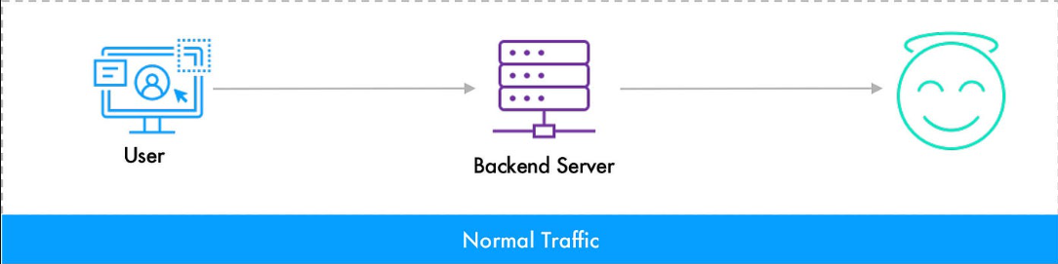
Figure 1: Illustration of Legitimate Traffic (Pre-DoS)
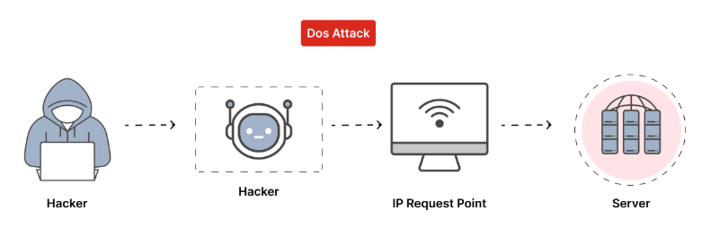
Figure 2: Example of DoS Attack
The project will compare various ML algorithms, including decision trees, support vector machines (SVM), random forests, and deep learning models, to determine the most effective technique for accurate detection. By analysing key features of network traffic and identifying anomalies indicative of DoS attacks, this project aims to contribute to the development of robust cybersecurity defences.
The outcome of this project will provide valuable insights into the applicability of ML for network security and help improve real-time detection and prevention mechanisms against DoS attacks.

Cyber Security Task: Intrusion Detection (Network)
Intrusion detection is essential in network security for identifying unauthorised access and malicious activities. This project focuses on detecting and preventing DoS (Denial-of-Service) attacks using machine learning techniques. DoS attacks disrupt network services by overwhelming them with excessive traffic, causing service unavailability and operational damage.
Traditional signature-based intrusion detection systems (IDS) often fail against evolving DoS attack patterns, as they rely on predefined attack signatures. ML-based detection, on the other hand, can analyse large volumes of network traffic, detect anomalies, and identify novel attack patterns in real-time. This project aims to develop and evaluate ML models capable of distinguishing normal and malicious network traffic to mitigate DoS threats effectively (Moustafa, 2017).

Justifications for selecting DoS Attack Detection
- Severe Impact on Network Availability – DoS attacks disrupt critical services, affecting businesses, government systems, and online platforms, making their detection a top security priority.
- Limitations of Traditional IDS – Signature-based IDS struggles with new and evolving attack patterns, while rule-based methods suffer from high false positives and computational inefficiencies.
- Effectiveness of Machine Learning – ML models can learn patterns, detect anomalies, and recognise unseen DoS attacks while continuously improving with more data.
- Relevance of the UNSW_NB15 Dataset – This dataset contains real-world normal and attack traffic, making it well-suited for training and testing ML models for DoS detection.

Objectives of the Cyber Security Task
Using the UNSW_NB15 dataset, we will extract key network features and apply various ML algorithms to classify traffic as normal or malicious (Garuba, 2018). The primary objectives of this cybersecurity task are:
- Feature Selection and Preprocessing: Identify and preprocess key network traffic features relevant to DoS attack detection.
- Model Training and Evaluation: Train multiple ML models (e.g., Decision Trees, SVM, Neural Networks) and compare their effectiveness.
- Real-Time Detection Enhancement: Explore how ML models can be deployed in an IDS for real-time DoS mitigation.
By leveraging ML techniques, this project aims to improve intrusion detection systems, enabling proactive defence against DoS attacks and enhancing overall network security.

Dataset – UNSW – NB15
Australian Centre for Cyber Security Institute created this dataset by using the IXIA PerfectStoem tool. Therefore, they use a mix of real modern normal activities and synthetic contemporary attack behaviours to build this perfect dataset (Australian Centre for Cyber Security (ACCS), 2019).

Dataset Description
The UNSW-NB15 dataset includes:
- 100 GB of row traffic, including nine types of cyber-attacks.
- More than 2.5 million records with 49 packet-based features.
- For easy use, there is a training set of 175,341 records and a testing set of 82,332 records for researchers.
- Free to use for academic research purposes.

Characteristics of the Dataset
- Project relevance
The dataset is more relevant to the research topic since it contains modern network traffic patterns, including DOS attacks.
- Comprehensiveness
The dataset provides different types of features (49) for the researchers to conduct a better analysis of modern network traffic.
- Attack type variation
The dataset contains various types of cyber-attacks, including DoS attacks. This will help train an accurate ML model to differentiate other attacks from DoS attacks.
- Widely usage
The dataset is widely used for network security-related research publications, and, therefore, we already have some knowledge about this data set.
- Availability
The Dataset is freely available to the public for academic usage.
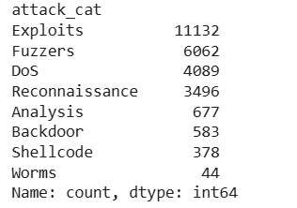
Figure 3: Attack Category Distribution in UNSW_NB15 Dataset

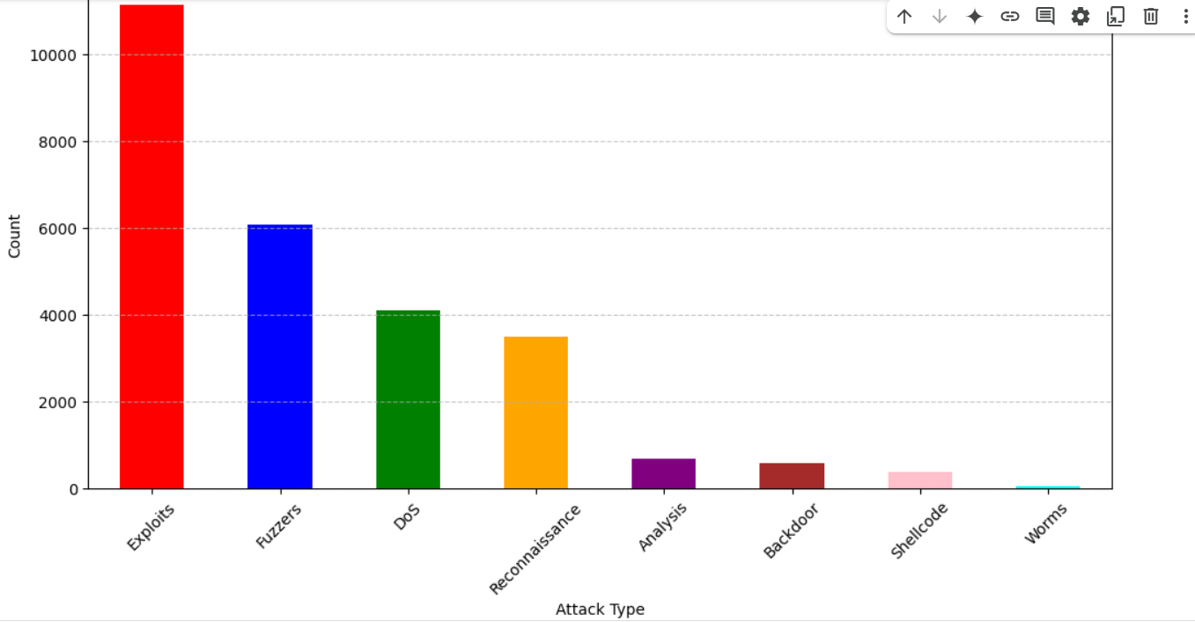
Figure 4: Bar Chart Showing the Counts of Different Attack Categories
ML Algorithms
Before training any ML model, it is necessary to clean the dataset. Therefore, we must remove null, duplicate, and noisy data. Moreover, we need to handle outliers and the data conversion to the correct data type, which impacts the train model accuracy.
Feature Selection
Feature selection or attribute selection is more important in accurately training ML models. In this process, the same as selecting the relevant features, we need to remove irrelevant features, which will provide additional value to the machine learning algorithm.

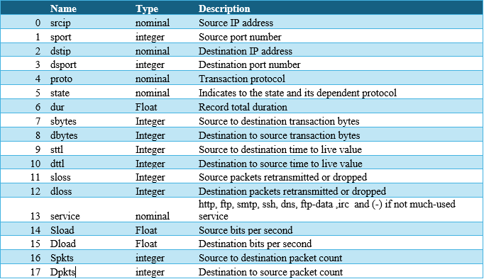
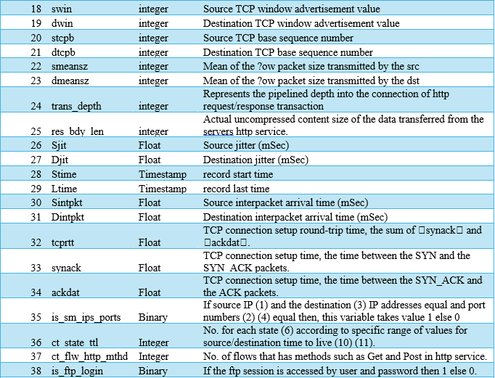
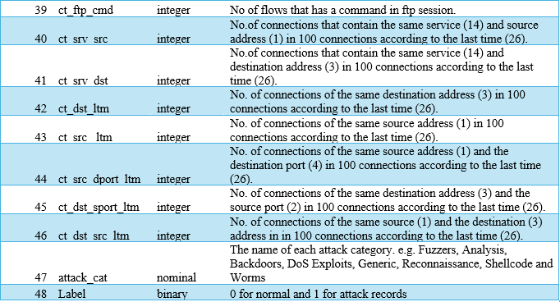
Table 1: List of Features in the Network Traffic Dataset

Dos attacks have characteristics that are relevant to their own. Most of them are targeted for the Network Bandwidth, Connection type and the time (TCP, UDP, TLS), Number of Sessions in the specific time period, and Hardware resource utilisation of the target host (Jisa David & Ciza Thomas, 2020).
Therefore, we can assume that the features below from the dataset can be highlighted as relevant to the Dos Attacks.
Key Network Traffic Features
dur | Record total duration (long spikes may indicate an attack)
sbytes | Source to destination transaction bytes (DoS attacks often involve excessive data)
dbytes | Destination to source transaction bytes
Spkts | Source to destination packet count
Dpkts | Destination to source packet count
Sload | Source bits per second (abnormal spikes indicate an attack)
Dload | Destination bits per second
TCP/UDP Behaviour Features
sttl | Source time to live (TTL) value
dttl | Destination TTL value
tcprtt | TCP connection setup round-trip time
synack | Time between SYN and SYN_ACK packets
ackdat | Time between SYN_ACK and ACK packets
is_sm_ips_ports | If source and destination IP/ports are the same, it could indicate a loop-based attack
Connection-Based Features
ct_srv_dst | Number of connections with the same destination service
ct_dst_ltm | Number of connections to the same destination in a short period
ct_src_dport_ltm | Number of connections from the same source to a specific port
Attack-Specific Features
attack_cat | Target variable (filter for DoS attacks only)
Label | Binary indicator (1 for attack, 0 for normal)

Random Forest
Random Forest is a powerful matching learning technique that can be used for classification and regression tasks. This algorithm is much better for complex data and the high-dimensional feature space (Antoine Gateraa, Martin Kuradusenge, Gaurav Bajpai, & Chomora Mikeka, 2023).
This ML algorithm can classify the relationship between the DoS attack and Normal traffic. By using multiple decision trees, this algorithm can classify the difference between the DoS attack network pattern and the Normal network pattern.
Random Forest can select the best relevant features by itself using its high-dimensional feature handle capability. However, we manually selected the above-mentioned features since we were going to compare the performance of the two different ML algorithms for the same feature set.
However, these ML algorithms show an accuracy of 0.98 for the UNSW -NB15 dataset.
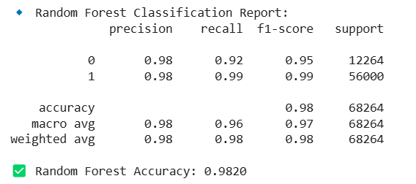
Figure 5: Random Forest Classification Report
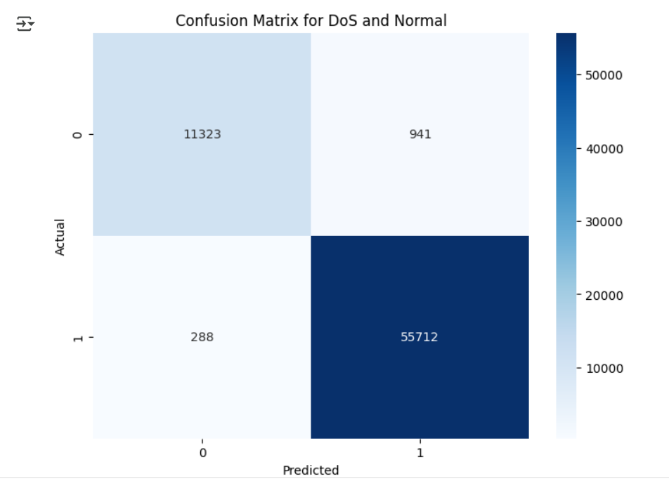
Figure 6: Confusion Matrix for DoS and Normal

Support Vector Machine (SVM)
SVM is designed to handle both classification and regression problems. In this project, we are going to predict DoS attacks by examining the relationship between DoS attacks and other network-related features in the UNSW -NB15 dataset (Antoine Gateraa, Martin Kuradusenge, Gaurav Bajpai, & Chomora Mikeka, 2023).
SVM can handle both linear and nonlinear relationships between data points. Therefore, the SVM model can identify underlying patterns in network traffic while effectively detecting DoS attacks.
Using highly relevant features, SVM provided high accuracy, as shown below.
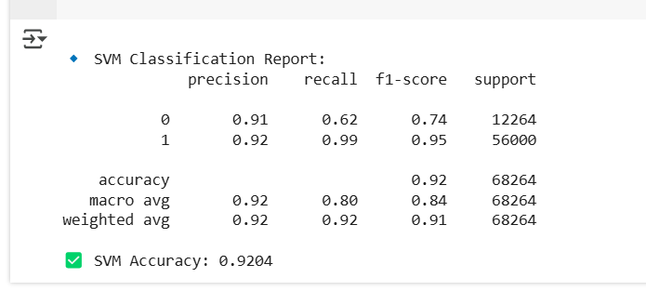
Figure 7: SVM Classification Report
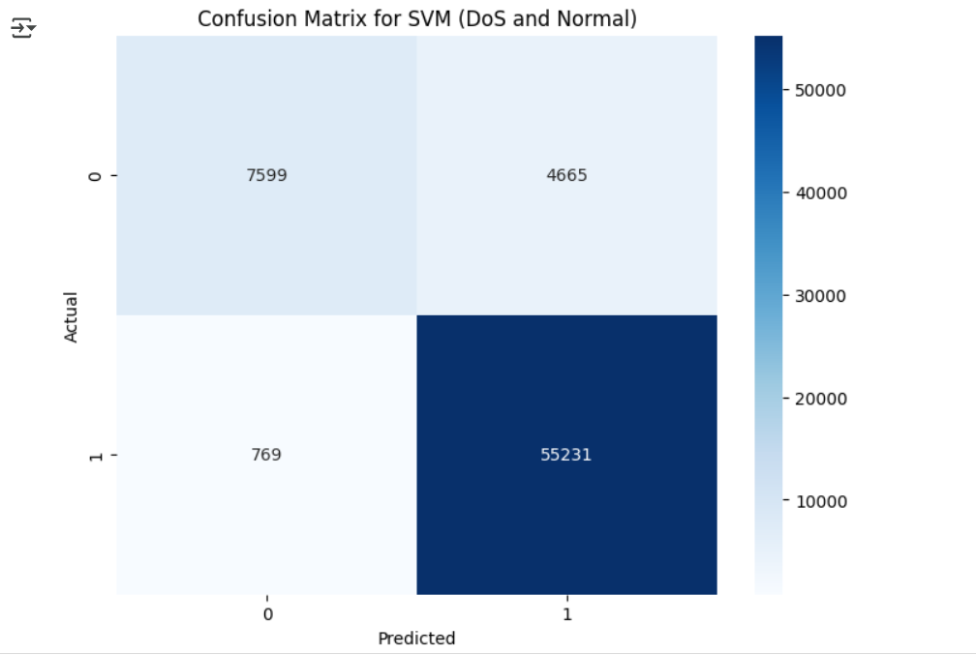
Figure 8: Confusion Matrix for SVM (DoS and Normal)

Potential Challenges & Mitigation Strategies
Challenge | Description | Mitigation Strategies
Data Preprocessing & Class Imbalance | The UNSW-NB15 dataset contains significantly more normal traffic than attack traffic, leading to model bias toward the majority class. | - Use resampling techniques (SMOTE, oversampling, under sampling).  - Apply class-weighted loss functions to penalise misclassification of minority classes.  - Employ ensemble learning to handle imbalanced data.  - Evaluate models using precision-recall curves instead of traditional accuracy.
Feature Selection & Engineering | The dataset has 49 features, and identifying the most relevant ones is crucial. Irrelevant or missing features can affect detection accuracy. | - Conduct feature importance analysis to select key features.  - Apply dimensionality reduction techniques (PCA, t-SNE) to remove redundant features.  - Use feature selection methods (RFE, L1 regularisation).  - Engineer new derived features to improve attack detection.
Model Generalisation & Adaptability | Models may overfit training data and fail to detect unseen DoS attack patterns in real-world network environments. | - Implement rigorous cross-validation techniques.  - Train models on diverse network traffic conditions.  - Evaluate performance on new attack types not seen in training.  - Use ensemble methods (bagging, boosting) to improve generalisation.

References
A.M. Aleesa1, *. M. (2021). Deep-Intrusion Detection System with Enhanced UNSW-NB15 Dataset Based on Deep Learning Techniques. Journal of Engineering Science and Technology, 711-727.
Antoine Gateraa, Martin Kuradusenge, Gaurav Bajpai, & Chomora Mikeka. (2023). Comparison of random forest and support vector machine. Scientific African.
Australian Centre for Cyber Security (ACCS). (2019). Retrieved from https://www.kaggle.com: https://www.kaggle.com/datasets/mrwellsdavid/unsw-nb15
Bagui, S. K. (2019). Using machine learning techniques to identify rare cyber-attacks on the UNSW-NB15 dataset. Security and Privacy, 2(5). Retrieved from https://doi.org/10.1002/spy2.91
Garuba, M. L. (2018). Intrusion techniques: Comparative study of network intrusion detection systems. Fifth international conference on information technology: new generations, 592-598.
Jisa David, & Ciza Thomas. (2020). Detection of distributed denial of service attacks based on information. Journal of Information Security and Applications.
Moustafa, N. C. (2017). Big data analytics for intrusion detection system: Statistical decision-making using UNSW-NB15 dataset. In Data Analytics and Decision Support for Cybersecurity. Springer, 127-156.
Muhammad Zeeshan, Q. R. (2021). Protocol-Based Deep Intrusion Detection for DoS and DDoS Attacks Using UNSW-NB15 and Bot-IoT Data-Sets. IEEE Access.
Souhail Meftah, T. R. (2019). Network Based Intrusion Detection Using the UNSW-NB15 Dataset. International Journal of Computing and Digital Systems.

